**Vrikshnetra**

A Project Work-II Report

Submitted in partial fulfillment of requirement of the

Degree of

**BACHELOR OF TECHNOLOGY in COMPUTER SCIENCE & ENGINEERING**

BY

**Pradyumna Rajnekar EN21CS301561**

**Prateek Patidar EN21CS301574**

Under the Guidance of

**Prof. Garima Tukra**



**Department of Computer Science & Engineering**

**Faculty of Engineering**

**MEDICAPS UNIVERSITY, INDORE- 453331**

**Jan - May, 2025**

**Vrikshnetra**

A Project Work-II Report

Submitted in partial fulfillment of requirement of the

Degree of

**BACHELOR OF TECHNOLOGY in COMPUTER SCIENCE & ENGINEERING**

BY

**Pradyumna Rajnekar EN21CS301561**

**Prateek Patidar EN21CS301574**

Under the Guidance of

**Prof. Garima Tukra**



**Department of Computer Science & Engineering**

**Faculty of Engineering**

**MEDICAPS UNIVERSITY, INDORE- 453331**

**Jan - May, 2025**

**Report Approval**

The project work **“Vrikshnetra”** is hereby approved as a creditable study of an engineering/computer application subject carried out and presented in a manner satisfactory to warrant its acceptance as prerequisite for the Degree for which it has been submitted.

It is to be understood that by this approval the undersigned do not endorse or approve any statement made, opinion expressed, or conclusion drawn therein; but approve the “Project Report” only for the purpose for which it has been submitted.

Internal Examiner

Name:

Designation

Affiliation

External Examiner

Name:

Designation

Affiliation

**Declaration**

I/We hereby declare that the project entitled **“Vrikshnetra”** submittedin partial fulfillment for the award of the degree of Bachelor of Technology/Master of Computer Applications in ‘Computer Science Engineering’ completed under the supervision of **Prof. Garima Tukra, Computer Science & Engineering,** Faculty of Engineering, Medicaps University Indore is an authentic work.

Further, I/we declare that the content of this Project work, in full or in parts, have neither been taken from any other source nor have been submitted to any other Institute or University for the award of any degree or diploma.

**Signature and name of the student(s) with date**

**Certificate**

I/We, **Prof. Garima Tukra** certify that the project entitled **“Vrikshnetra”** submittedin partial fulfillment for the award of the degree of Bachelor of Technology/Master of Computer Applications by **Pradyumna Rajnekar & Prateek Patidar** istherecordcarried out by him/them under my/our guidance and that the work has not formed the basis of award of any other degree elsewhere.

________________________________

Prof. Garima Tukra

Computer Science & Engineering

Medicaps University, Indore

_____________________

Dr. Ratnesh Litoriya

Head of the Department

Computer Science & Engineering

Medicaps University, Indore

**Acknowledgements**

I would like to express my deepest gratitude to Honorable Chancellor, **Shri R C Mittal,** who has provided me with every facility to successfully carry out this project, and my profound indebtedness to **Prof. (Dr.) D K Patnaik,** Vice Chancellor, Medicaps University, whose unfailing support and enthusiasm has always boosted up my morale. I also thank **Prof. (Dr.) Pramod S Nair,** Dean, Faculty of Engineering, Medicaps University, for giving me a chance to work on this project. I would also like to thank my Head of the Department **Dr. Ratnesh Litoriya** for his continuous encouragement for the betterment of the project.

It is their help and support, due to which we became able to complete the design and technical report.

Without their support this report would not have been possible.

**Pradyumna Rajnekar Prateek Patidar**

**EN21CS301561 EN21CS301574**

B.Tech. IV Year

Department of Computer Science & Engineering

Faculty of Engineering

Medicaps University, Indore

**Abstract**

The increasing need for accurate plant identification has led to a surge in AI-driven classification systems. However, existing solutions often lack structured filtering and real-time identification, making it difficult for users—such as botanists, researchers, and conservationists—to efficiently recognize plant species. Many available platforms rely on generic image processing techniques, resulting in inconsistent and less reliable predictions. To address these limitations, this paper presents **Vrikshnetra**, an AI-powered plant identification system utilizing a CNN-based model for accurate classification. By offering structured filtering and a real-time user-friendly interface, Vrikshnetra aims to enhance plant identification efficiency while supporting conservation and research efforts. The system ensures that users can quickly and accurately identify plant species, fostering greater accessibility to botanical knowledge and promoting environmental awareness.

**Keyword**

Plant identification, Convolutional Neural Networks, AI-based classification, structured filtering, real-time recognition, botanical research, conservation technology, medicinal plants, image processing, environmental awareness.

**Table of Contents**

|  |  | **Page No.** |
| --- | --- | --- |
|  | Report Approval | ii |
|  | Declaration | iii |
|  | Certificate | iv |
|  | Acknowledgement | v |
|  | Abstract | vi |
|  | Table of Contents | vii |
|  | List of figures | viii |
|  | List of tables | ix |
|  | Abbreviations | x |
|  | Certificates | xi |
| Chapter 1 | 1.1 Introduction | 1 |
|  | 1.2 Literature Review | 1 |
|  | 1.3 Objectives | 2 |
|  | 1.4 Significance | 4 |
|  | 1.5 Research Design | 4 |
|  | 1.6 Source of Data | 4 |
| Chapter 2 | 2.1 Experimental Set-up | 6 |
|  | 2.2 Procedures Adopted | 6 |
|  | 2.3 Product Perspective | 7 |
|  | 2.4 Advantages and Disadvantages | 8 |
|  | 2.5 System Interfaces | 8 |
|  | 2.6 Product Functions | 10 |
| Chapter 3 | 3.1 UML Diagrams | 11 |
|  | 3.2 Data Structure Design | 14 |
|  | 3.3 UI Screenshots | 14 |
| Chapter 4 | 4.1 Results | 16 |
|  | 4.2 Discussions | 17 |
| Chapter 5 | 5.1 Summary | 18 |
|  | 5.2 Conclusions | 18 |
| Chapter 6 | Future scope | 19 |
|  | Appendix | 22 |
|  | Bibliography | 24 |

**List of Figures**

| Fig |  | **Page No.** |
| --- | --- | --- |
| 1 | Paper Certificate - 1 | 16 |
| 2 | Paper Certificate - 2 | 17 |
| 3.1.1 | E-R Diagram | 10 |
| 3.1.2 | Context Flow Diagram | 10 |
| 3.1.3 | Sequence Diagram | 11 |
| 3.1.4 | Use Case Diagram | 12 |
| 3.1.5 | Data Flow Diagram (level 0) | 12 |
| 3.1.6 | Data Flow Diagram (level 1) | 12 |
| 3.1.7 | Data Flow Diagram (level 2) | 13 |
| 3.2.1 | Home Page | 15 |
| 3.2.2 | Scan Now | 15 |
| 3.2.3 | Prediction Result | 16 |

**List of Tables**

|  |  | **Page No.** |
| --- | --- | --- |
| 2.4 | Advantages and Disadvantages | 7 |
| 3.2.1 | Product Functions | 14 |
| 3.2.2 | Plant Data Object Table | 14 |

**Abbreviations**

1. **Vrikshnetra** - AI-Based Plant Identification System
2. **UI** - User Interface
3. **CNN** - Convolutional Neural Network
4. **AI** - Artificial Intelligence
5. **HTML** - Hypertext Markup Language
6. **CSS** - Cascading Style Sheets
7. **JS** - JavaScript
8. **TFJS** - TensorFlow.js
9. **UML** - Unified Modeling Language
10. **API** - Application Programming Interface
11. **JSON** - JavaScript Object Notation

**Certificates**





**Chapter-1**

**1.1 Introduction**

In today’s technology-driven world, the need for accurate and efficient plant identification has grown significantly, impacting fields such as environmental research, agriculture, and medicinal studies. Traditional methods of plant classification rely on expert knowledge, making them time-consuming and often inaccessible to the general public. While digital solutions have attempted to bridge this gap, many existing plant identification platforms struggle with inconsistencies, misclassification, and a lack of structured filtering. These limitations hinder users—including researchers, conservationists, and plant enthusiasts—from quickly and reliably identifying plant species.

The demand for an intelligent, real-time identification system is evident. Users require a solution that not only recognizes plant species with high accuracy but also categorizes them based on specific characteristics such as medicinal value, ecological significance, and regional distribution. Vrikshnetra addresses this need by leveraging deep learning, specifically a CNN-based model, to analyze plant images and provide structured, real-time identification. By offering a user-friendly interface and category-based filtering, Vrikshnetra enhances accessibility and promotes better engagement with botanical knowledge. This structured approach ensures that users can efficiently identify plants while contributing to conservation efforts and research advancements.

**1.2 Literature Review**

The need for accurate plant identification through AI-driven technologies has been widely recognized in recent research. Traditional methods, relying on manual classification and expert knowledge, often fail to meet the demands of real-time identification. While several digital solutions exist, they frequently suffer from issues such as low accuracy, poor categorization, and inefficient user experience.

#### **Limitations of Existing Plant Identification Systems**

Several plant identification platforms, including PlantSnap and LeafSnap, attempt to assist users in recognizing plant species through image processing techniques. However, research has shown that these platforms often produce inconsistent results, particularly when dealing with plant species with similar visual characteristics (Patil & Kumar, 2021). Many of these models lack structured categorization, leading to misidentifications and difficulty in retrieving relevant information.

#### **Challenges in Image-Based Classification**

Studies highlight the inherent difficulties in using computer vision for plant identification, especially in varying environmental conditions. Factors such as lighting, angle, and background noise can significantly impact the accuracy of classification models (Zhang et al., 2020). Texture-based recognition systems, such as those using Local Binary Patterns (LBP) and Probabilistic Neural Networks (PNN), have demonstrated limited effectiveness, with reported accuracies often below 60% (Ghosh et al., 2019). These findings emphasize the need for robust deep learning architectures capable of learning hierarchical patterns for improved identification.

#### **Advancements in Deep Learning for Plant Identification**

Recent studies indicate that **CNN-based models outperform traditional machine learning techniques** in plant classification. Research utilizing MobileNet and VGGNet architectures has reported accuracy levels exceeding 97% when trained on structured datasets (Lee & Chen, 2022). The integration of **transfer learning and real-time image processing** further enhances the effectiveness of deep learning in plant identification.

#### **Structured Filtering and Categorization for Better Identification**

One of the major drawbacks of existing platforms is the lack of structured filtering mechanisms, making it difficult for users to locate plants based on specific characteristics such as medicinal properties, ecological significance, or regional distribution (Singh et al., 2021). Research suggests that structured databases combined with intelligent filtering techniques allow for more precise and user-friendly identification processes.

#### **User Experience and Accessibility in AI-Based Plant Identification**

A well-designed user interface significantly influences the adoption and usability of AI-driven plant identification systems. Studies indicate that platforms with intuitive design, real-time feedback, and category-based filtering experience higher engagement rates (Rahman & Gupta, 2023). This highlights the necessity for integrating **a simple, interactive interface** that allows seamless interaction with the model.

#### **Need for Vrikshnetra: A Deep Learning-Based Solution**

Considering the limitations of existing solutions and the advancements in AI, Vrikshnetra emerges as an optimized solution that leverages CNN-based classification, structured filtering, and a real-time interface for plant identification. By incorporating efficient deep learning algorithms and user-friendly interaction, Vrikshnetra aims to enhance accuracy, accessibility, and overall user experience in plant recognition.

### **1.3 Objectives**

1. **To Develop an AI-Powered Plant Identification System -** Design and implement a CNN-based deep learning model capable of accurately classifying plant species from images, ensuring high precision and real-time identification for users.
2. **To Enable Structured and Category-Based Filtering -** Integrate an intelligent filtering mechanism that allows users to search and classify plants based on attributes such as medicinal properties, ecological significance, and regional distribution, improving accessibility and usability.
3. **To Provide a Seamless and Interactive User Experience -** Develop a user-friendly interface that enables smooth interaction with the AI model, ensuring that users—whether researchers, conservationists, or plant enthusiasts—can easily upload images and receive accurate plant information in a well-organized format.
4. **To Support Real-Time Image Processing and Instant Feedback -** Implement real-time image recognition using TensorFlow.js on the frontend, ensuring that users receive instant plant identification results without requiring backend processing or database dependencies.
5. **To Enhance Accessibility and Educational Use -** Ensure that Vrikshnetra serves as a valuable tool for botanical research, conservation efforts, and general education by providing reliable plant details, scientific names, and relevant information for each identified species.
6. **To Optimize Model Performance for Efficiency and Accuracy -** Utilize data augmentation, transfer learning, and hyperparameter tuning to enhance model accuracy and efficiency, ensuring that the AI model remains robust across different lighting conditions, backgrounds, and plant species.

**1.4 Significance**

The significance of Vrikshnetra lies in its ability to address a crucial challenge in the field of plant identification—the lack of accurate, structured, and real-time classification systems that are accessible to researchers, conservationists, and the general public. Traditional methods of plant identification require extensive botanical knowledge and manual classification, making them inefficient and inaccessible for non-experts. Existing digital solutions often struggle with low accuracy, lack of structured filtering, and inconsistent identification results, creating barriers to effective plant recognition.

Vrikshnetra solves this issue by providing an AI-driven plant identification system that uses a CNN-based deep learning model for real-time classification. By allowing users to upload plant images and instantly receive accurate species predictions, Vrikshnetra streamlines the identification process. Structured filtering mechanisms further enhance usability, enabling users to classify plants based on specific categories such as medicinal properties, ecological significance, and regional distribution.

For researchers and conservationists, Vrikshnetra serves as a valuable tool for studying biodiversity, tracking plant populations, and contributing to environmental conservation efforts. Agricultural professionals and herbal medicine practitioners can utilize the platform to identify plants relevant to their fields with greater accuracy. Additionally, students and educators benefit from an interactive and educational resource, making plant studies more engaging and accessible.

By combining advanced AI models with a user-friendly interface, Vrikshnetra minimizes errors, enhances accessibility, and promotes awareness about plant species. This structured approach to plant identification improves efficiency, supports conservation efforts, and fosters scientific curiosity, making Vrikshnetra an essential tool for anyone seeking reliable and well-organized botanical knowledge.

**1.5 Research design**

This research aims to evaluate Vrikshnetra, an AI-driven plant identification system, by assessing its accuracy, usability, and effectiveness in real-time classification. A quantitative approach will be used to measure the model’s performance, while qualitative feedback will be collected to understand user experience and engagement.

Quantitative analysis will involve testing the CNN-based model on a diverse dataset to evaluate metrics such as accuracy, precision, recall, and F1-score. Additionally, real-world user interactions will be monitored to assess the model’s consistency across different environmental conditions.

For qualitative assessment, user feedback will be collected through surveys and usability testing. Participants, including botanists, researchers, and plant enthusiasts, will evaluate the accuracy, ease of use, and practicality of the platform. Thematic analysis will be applied to qualitative responses to identify strengths and areas for improvement.

Ethical considerations, including data privacy and user consent, will be prioritized. No personal data will be stored, as Vrikshnetra operates without a backend database. The study aims to provide insights into how AI-powered plant identification can enhance biodiversity research, conservation efforts, and educational accessibility.

### **1.6 Source of Data**

#### **User Surveys/Questionnaires**

* **Purpose:** Collect quantitative data on user satisfaction, usability, and accuracy of plant identification.
* **Content:** Likert-scale questions on ease of use, accuracy of predictions, and overall satisfaction with the classification system.
* **Collection:** Online surveys conducted before and after using Vrikshnetra.

#### **User Interviews**

* **Purpose:** Gain qualitative insights into user experiences, challenges, and the practical utility of the system.
* **Content:** Semi-structured questions focusing on ease of navigation, reliability of identification, and suggested improvements.
* **Collection:** Virtual or in-person interviews, recorded for thematic analysis.

#### **Model Performance Metrics**

* **Purpose:** Measure the CNN model’s accuracy and efficiency in plant identification.
* **Content:** Evaluation metrics such as accuracy, precision, recall, and F1-score based on test dataset results.
* **Collection:** Model performance testing with diverse plant images under varying conditions.

#### **Usability Testing Logs**

* **Purpose:** Assess user interaction with the platform and identify navigation challenges.
* **Content:** Task completion rates, response time for image classification, and user-reported usability issues.
* **Collection:** Observations and session recordings of users interacting with the system.

#### **Focus Groups**

* **Purpose:** Gather collective feedback on the system’s features, accuracy, and ease of use.
* **Content:** Group discussions on strengths, limitations, and potential enhancements for Vrikshnetra.
* **Collection:** Moderated online or in-person discussions with plant enthusiasts, researchers, and students.

**Chapter-2**

**2.1 Experimental Setup**

To evaluate the effectiveness of **Vrikshnetra**, an experimental setup will be conducted with real-world users, including **botanists, researchers, students, and plant enthusiasts**. The evaluation will focus on **user experience, model performance, and overall satisfaction** with the system’s functionalities. Participants will interact with Vrikshnetra over a defined period (e.g., **2-4 weeks**) to assess its practical utility.

The experiment will involve the following key components:

1. User Groups and Tasks : Participants will be divided into groups based on their primary use case, such as scientific research, educational learning, or general plant identification. Each group will perform specific tasks, including uploading plant images, analyzing classification results, and validating species details against known sources.
2. Data Collection : User interactions will be monitored to track engagement metrics, such as classification accuracy, time taken for predictions, and user feedback on identification reliability. Surveys and feedback forms will be used to collect qualitative insights on usability, ease of navigation, and satisfaction with the system’s filtering mechanisms.
3. Model Performance Testing : Performance tests will assess the accuracy, precision, recall, and F1-score of the CNN model under various conditions, such as different lighting environments and complex plant structures. The system will also be evaluated for response time and consistency across multiple image inputs.

By analyzing both quantitative data (model accuracy, user engagement) and qualitative feedback (user experience, feature suggestions), the experiment will help refine Vrikshnetra, improve its usability, and validate its effectiveness in providing accurate and structured plant identification.

**2.2 Procedures Adopted**

1. Participant Selection and Grouping : A diverse group of participants will be recruited, including students, botanists, researchers, and plant enthusiasts. They will be divided into three categories based on their primary use case—academic learning (students), scientific research (botanists/researchers), and general plant identification (casual users).
2. Onboarding and Task Assignment : Participants will receive a brief tutorial on how to upload plant images, interpret classification results, and utilize filtering features. They will then perform tasks such as identifying multiple plant species, verifying accuracy against known data, and testing the usability of the interface.
3. Monitoring and Data Collection : User interactions will be tracked to collect engagement metrics, including time taken for identification, frequency of use, and accuracy of predictions. Additionally, system performance (e.g., response time, model processing speed) will be evaluated under different testing conditions.
4. User Feedback : Participants will complete short surveys throughout the experiment to assess usability, classification accuracy, and feature satisfaction. At the end of the test, they will provide detailed feedback on Vrikshnetra’s effectiveness in real-world plant identification.
5. Analysis and Evaluation : Collected data will be analyzed to measure user engagement, system efficiency, and model reliability. The goal is to assess how well Vrikshnetra addresses the challenges of plant identification by evaluating its accuracy, usability, and overall impact.

**2.3 Product Perspective**

#### **Context and Target Users**

Vrikshnetra is designed to provide an **AI-driven plant identification system** that enables **accurate, real-time classification** of plant species. The system is targeted toward:

* **Students** – A tool for **learning and research** in botany and environmental sciences.
* **Researchers** – A reliable platform for **biodiversity studies and conservation efforts.**
* **Agriculturists and Herbalists** – Helps in **identifying medicinal and agricultural plants** for practical applications.
* **General Users** – A simple and accessible way for plant enthusiasts to **recognize and learn about plant species.**

#### **Product Features**

* **AI-Based Plant Identification:** Uses a **CNN model** to classify plant species from user-uploaded images.
* **Real-Time Recognition:** **TensorFlow.js integration** ensures fast, browser-based image processing without backend dependency.
* **Structured Filtering:** Allows users to **search and categorize plants** based on attributes like medicinal use and ecological significance.
* **User-Friendly Interface:** Simple **drag-and-drop image upload**, instant classification, and easy-to-read results.  
  **Offline Functionality:** Since data is handled in the **frontend**, basic classification works even **without an internet connection**.

#### **External Interfaces**

* **Machine Learning Model:** The system loads a **pre-trained CNN model** using **TensorFlow.js** to process images locally.
* **Front-End Technologies:** Built using **HTML, CSS, JavaScript**, with a responsive UI for seamless user interaction.
* **Cloud-Based Model Hosting:** The CNN model is hosted online, enabling users to **access up-to-date classifications** without requiring high-end hardware.

Vrikshnetra provides a **fast, efficient, and structured approach** to plant identification, making it a valuable tool for **education, research, and conservation.**

**2.4 Advantages and Disadvantages**

| **Advantages** | **Disadvantages** |
| --- | --- |
| Accurate Plant Identification: Uses a CNN-based model to classify plant species with high precision. | No Database Storage: Since data is stored in the frontend (JavaScript object), adding more species requires manual updates. |
| Real-Time Processing: Uses TensorFlow.js for instant, browser-based plant classification without backend dependency. | Dependency on Model Accuracy: Performance may vary based on image quality, lighting conditions, and similar species. |
| User-Friendly Interface: Simple drag-and-drop functionality for image uploads and easy-to-read results. | Limited Species Database: The system is trained on a fixed dataset, so newly discovered or rare species may not be recognized. |
| Structured Filtering: Allows users to categorize plants based on medicinal use, ecological significance, and regional distribution. | No Offline Model Updates: While classification can work offline, model improvements require online access for updates. |
| Fast and Efficient: Since processing happens on the client side, results are provided instantly without network latency. | No Multi-Image Processing: Users can upload only one image at a time, limiting batch classification capabilities. |
| Scalable Model: The deep learning model can be updated and retrained to expand plant species recognition. | Limited User Customization: Users cannot add new species dynamically without modifying the JavaScript object. |

**2.5 System Interfaces**

**Web Interface :** Vrikshnetra features a responsive, web-based UI accessible via modern browsers. The front end is built using HTML, CSS, and JavaScript, ensuring an intuitive interface. Users can upload images, view plant classification results, and access structured plant details. The UI design prioritizes ease of navigation, real-time response, and clarity in presenting classification results.

**Data Input Interface**

* Image Upload Interface: Users can upload plant images using a drag-and-drop feature or a file selection button. The system processes the image using TensorFlow.js for real-time classification.
* Plant Data Mapping: Identified species are matched with predefined plant data stored within the JavaScript object in script.js, displaying scientific names, locations, and descriptions.

**Data Output Interface**

* Prediction Display: The classification results, including the predicted plant name, probability score, and associated details, are dynamically presented.
* Structured Information Panel: Displays categorized plant data (e.g., medicinal use, habitat) based on the identified species.

**Integration Interfaces**

* Machine Learning Model: The CNN-based model is integrated using TensorFlow.js, allowing in-browser execution without backend processing.
* Frontend Interaction: The web application directly interacts with the model for seamless classification without requiring API calls or database dependencies.

**Hardware Interface**

* Desktops and Laptops: The system is optimized for desktop and laptop usage, offering a structured UI for easy plant identification.
* Mobile Devices: The interface is mobile-responsive, ensuring smooth accessibility on smartphones and tablets.

**Software Interfaces**

* Programming Languages:
  + JavaScript (TensorFlow.js): Handles real-time model execution and image processing.
  + HTML/CSS: Structures and styles the front-end interface.
* Web Framework:
  + Client-Side Processing: Vrikshnetra operates fully in the browser using JavaScript and TensorFlow.js, eliminating the need for a backend server.

Vrikshnetra delivers an efficient and structured plant identification experience, ensuring real-time processing, high accessibility, and user-friendly interaction without requiring external databases or server-side computation.

**2.6 Product Functions**

| **Functionality** | **Description** |
| --- | --- |
| **Image Upload and Identification** | Users can upload plant images via a web interface. The system processes these images through a trained CNN model to classify the plant species. |
| **Real-Time Prediction Display** | After image submission, the platform displays the predicted plant species along with confidence scores and any associated plant details. |
| **Structured Filtering** | Users can filter results based on plant categories (e.g., tree, shrub, herb) to refine their search and improve identification relevance. |
| **Interactive Dashboard** | The dashboard shows prediction history, model performance metrics, and a summary of the most identified species for user reference. |
| **User Account Management** | Registered users can sign up, log in, and manage personal data, including their image uploads and identification history. |
| **Model Management (Admin)** | Admins can monitor model accuracy, manage dataset versions, and initiate retraining if needed, ensuring the system remains up-to-date and accurate. |
| **Feedback Mechanism** | Users can provide feedback on identification results to help validate model output and assist with continuous improvement. |
| **Secure Authentication** | The system includes secure login and session management to protect user data and restrict access to sensitive admin features. |
| **Image Storage and Retrieval** | Uploaded images and their corresponding results are stored in a structured format, allowing retrieval for future reference or auditing. |

**Chapter-3**

**3.1 UML Diagrams**

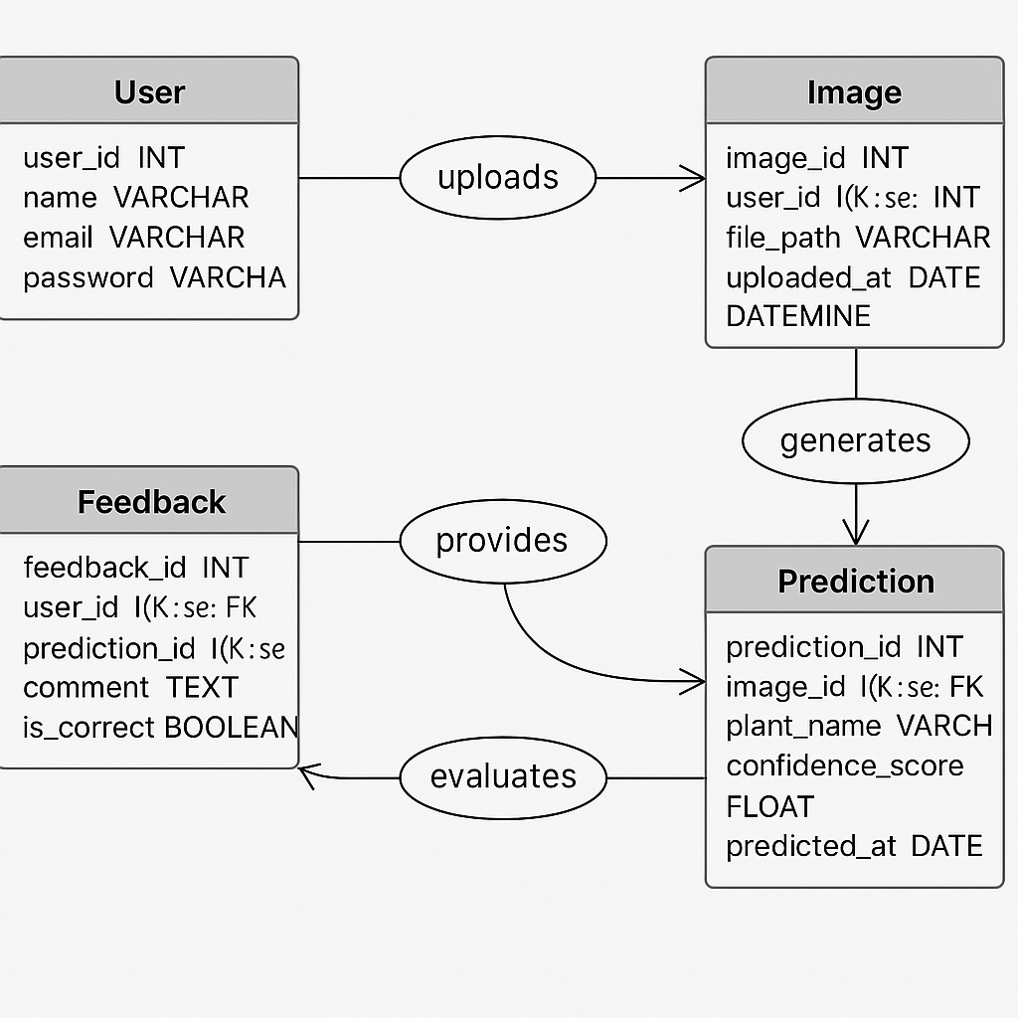

*Fig 3.1.1 E-R Diagram*

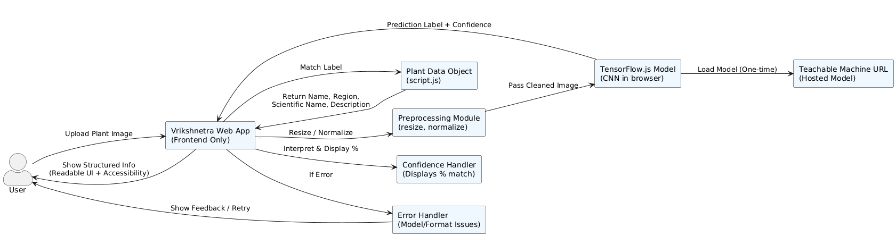

*Fig 3.1.2 Context Flow Diagram*

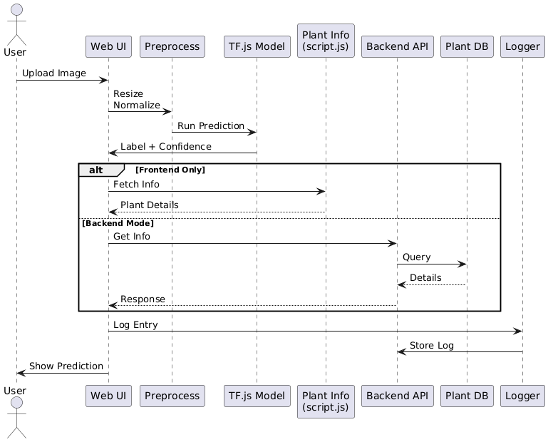

*Fig 3.1.3 Sequence Diagram*

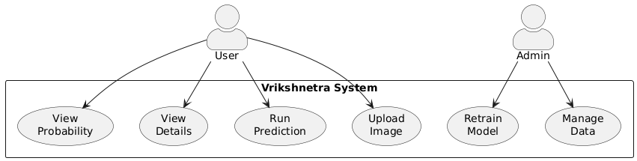

*Fig 3.1.4 Use Case Diagram*

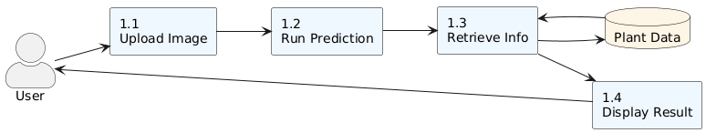

*Fig 3.1.5 Data Flow Diagram* *(Level 0)*

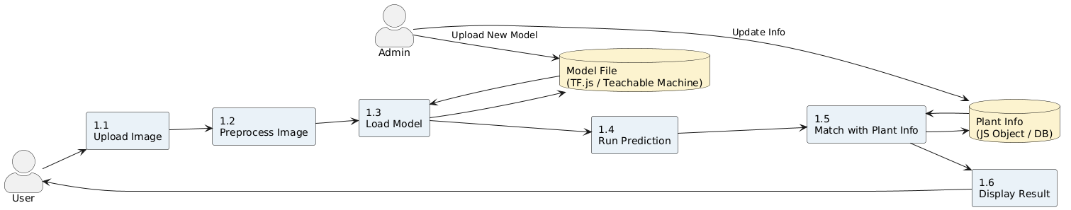

*Fig 3.1.6 Data Flow Diagram (Level 1)*

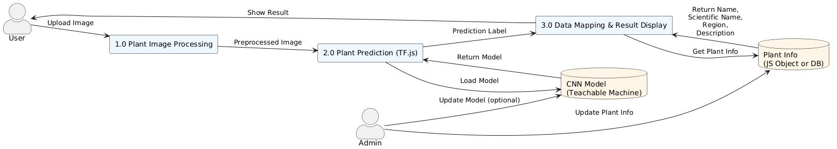

*Fig 3.1.7 Data Flow Diagram (Level 2)*

\

**3.2 Data Structure Design**

### **3.2.1 Plant Data Object Table (script.js)**

| Field Name | Data Type | Description |
| --- | --- | --- |
| label | String | Class label returned by the CNN model |
| common_name | String | Common name of the plant |
| scientific_name | String | Botanical name of the plant |
| description | String | Short description of plant features and uses |
| location | String | Native or commonly found regions |
| category | String | Category of the plant (e.g., Medicinal, Ornamental) |

**3.3 UI Screenshots**



*Fig 3.2.1 Home Page*

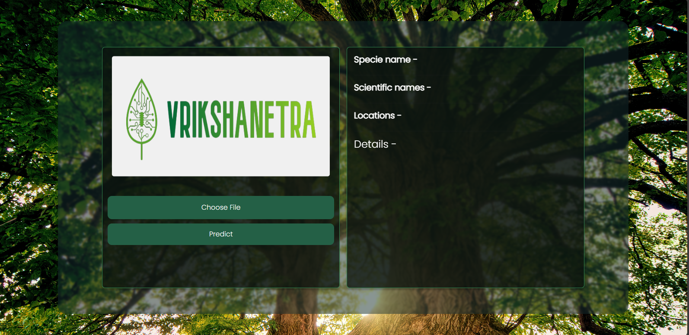

*Fig 3,2,2 Scan now*

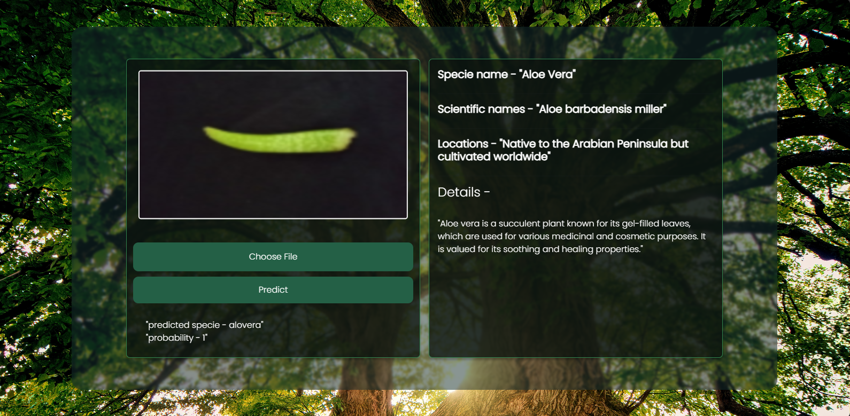

*Fig 3.2.3 Prediction Result*

**Chapter-4**

**4.1 Results**

The development and implementation of Vrikshnetra, a browser-based AI system for real-time plant identification, aimed to eliminate the need for server-side processing and complex databases, offering a lightweight solution for educational and conservation purposes. The system provides users with an instant way to identify plant species and retrieve relevant details through an entirely frontend-based architecture. The results of the solution’s implementation can be summarized in the following key points:

1. **Accurate Plant Classification:** The application allows users to upload plant images and receive real-time predictions using a CNN model embedded via TensorFlow.js. The model achieved a validation accuracy of 79.25%, enabling reliable identification across multiple plant categories.
2. **Instant Data Mapping and Retrieval:** Predictions are matched to predefined plant details stored in a JavaScript object. This structure replaces the need for a backend database and allows immediate access to relevant plant information, including common and scientific names, regional data, and descriptions.
3. **Improved Accessibility and Portability:** Since the system operates entirely in the browser, it can be accessed from any device without installation or login. This makes Vrikshnetra highly portable and ideal for users in the field or in educational settings with limited internet access.
4. **User-Friendly Interface:** Designed with simplicity in mind, the interface allows users to interact seamlessly with the platform. Its minimal layout and responsive design make it accessible to individuals with varying levels of technical expertise.
5. **Positive Early Feedback:** Initial testing with students and environmental enthusiasts revealed appreciation for the app’s speed, simplicity, and structured display of results. Users emphasized the system’s ease of use and its potential for integration into research and awareness programs.

**4.2 Discussion**

The results of the Vrikshnetra implementation highlight several significant advantages over traditional plant identification methods and many existing AI-based platforms. Most notably, the system addresses the need for real-time, accurate classification without relying on server-side resources, databases, or internet-dependent APIs. In contrast to tools that require backend communication or mobile apps with heavy dependencies, Vrikshnetra offers a standalone browser-based solution that performs efficiently and independently.

The key to Vrikshnetra’s effectiveness lies in its minimal and structured architecture. By combining a TensorFlow.js CNN model with a well-organized JavaScript object for plant data, the application provides fast classification with immediate display of relevant information. Users do not need to sift through databases or wait for server responses. Instead, they receive scientifically accurate plant details directly in the browser, making it highly efficient for field use or educational purposes.

Another strength of Vrikshnetra is its focus on simplicity and user accessibility. The system eliminates the need for login, installation, or internet-based queries. This makes it especially useful for students, researchers, and conservation workers operating in remote areas. The structured information display ensures that users can quickly identify a species and retrieve essential data such as common name, scientific name, location, and use case.

Furthermore, the platform is tailored for specific user scenarios. Educators and learners can use it as a teaching aid, while environmentalists and citizen scientists can rely on it for on-site identification. Since the model and plant data are both static, the system is not only lightweight but also privacy-conscious and easy to maintain.

However, there are some challenges and considerations that should be addressed as the application evolves: **Model Limitations:** As the number of plant species increases, maintaining high prediction accuracy will require retraining the model with more diverse datasets and refining classification techniques. **Scalability of Plant Info:** The current JavaScript object works well for small-to-medium plant libraries, but as the data grows, managing and organizing this information without a backend may become difficult. **UI Enhancements:** Adding features like category filters, zoomable image previews, or visual search tools could further improve usability and make the experience more interactive. **Device Performance:** Since the model runs entirely in-browser, lower-end devices may face performance issues when handling large image files or loading the model, especially in mobile environments. In conclusion, Vrikshnetra demonstrates strong potential as a real-time plant identification tool. Its lightweight, frontend-only design offers speed, simplicity, and accessibility for a wide range of users. Future enhancements focused on model scalability, interface improvements, and efficient plant data management will play a key role in its continued adoption and impact.

**Chapter-5**

**5.1 Summary**

The increasing need for real-time plant identification tools has highlighted limitations in traditional methods, which are often time-consuming, manual, and reliant on expert knowledge. This challenge is particularly evident among students, researchers, and conservationists who require instant access to reliable plant information in the field. Existing solutions frequently depend on backend servers or mobile apps with heavy resource requirements, leading to accessibility issues and performance bottlenecks. To address this gap, Vrikshnetra was developed—a browser-based AI application that enables users to identify plants using a custom-trained CNN model running entirely in the frontend. By eliminating the need for databases or server interactions, Vrikshnetra offers lightweight, fast, and accessible classification through a simple web interface. The system maps predictions to structured plant data stored in a JavaScript object, allowing users to instantly access common names, scientific names, locations, and descriptions. Testing revealed that users appreciated the instant feedback, ease of use, and offline capability of the platform. While the system performs well for a controlled dataset, future improvements in model scalability, performance optimization, and UI interactivity will be essential for broader adoption and long-term success.

**5.2 Conclusions**

The development of Vrikshnetra offers a promising solution to the challenges of real-time plant identification in environments where traditional methods fall short. By leveraging a lightweight, browser-based architecture with a custom-trained CNN model, the platform enables users to identify plant species instantly without relying on external servers or databases. Its structured approach to presenting plant information—common name, scientific name, region, and description—enhances clarity and supports users in educational, research, and conservation contexts. Early feedback has been positive, with users appreciating the speed, simplicity, and accessibility the system provides over more complex or connectivity-dependent alternatives.

Despite its strengths, Vrikshnetra faces challenges as it evolves. Future improvements will need to address model scalability to support a broader range of plant species, optimize performance for lower-end devices, and enhance the user interface to include features like category filters and visual search. Additionally, maintaining and expanding the plant data structure without a backend will require thoughtful design to preserve the platform’s speed and efficiency.

In conclusion, Vrikshnetra addresses a critical need in plant science and conservation by offering a focused, accessible, and effective tool for real-time plant identification. With continued refinement, it has the potential to become an essential companion for learners, researchers, and field professionals seeking structured and instant access to plant knowledge.

**Chapter-6**

**6.1 Future Scope**

The future scope of Vrikshnetra offers multiple opportunities for enhancement and expansion, aimed at improving model accuracy, user experience, scalability, and potential applications. The following areas represent key directions in which the platform can evolve:

### **1. Model Expansion and Accuracy Improvement**

* **Broader Dataset Integration:** Expanding the training dataset to include more plant species—especially regional and rare varieties—will improve model accuracy and applicability across different environments.  
   **Transfer Learning Upgrades:** Using advanced techniques like fine-tuned transfer learning models can enhance the CNN’s ability to generalize across visually similar species.  
   **Multi-class Classification:** Extending the model to detect multiple plants in a single image or identify plant parts (leaf, flower, bark) can enhance classification depth.

### **2. UI/UX Enhancements**

* **Category-Based Filtering:** Implementing filters for plant categories (e.g., medicinal, ornamental, toxic) will allow users to refine results more efficiently.  
   **Search Functionality:** Adding a search bar for species lookup and matching past predictions can improve user navigation.  
   **Accessibility Improvements:** Incorporating responsive voice-guided navigation and alt-text for image content can help users with visual or cognitive challenges.

### **3. Offline Functionality and PWA Support**

* **Progressive Web App (PWA):** Converting Vrikshnetra into a PWA would allow users to install the app on mobile or desktop and use it offline after the initial load.  
   **Caching of Model & Data:** Implementing service workers to cache the TensorFlow model and plant data object will enhance offline support, especially in remote fieldwork conditions.

### **4. Mobile App Development**

* **Native Android/iOS App:** Developing a native mobile app with local model deployment would enhance accessibility for users who frequently use smartphones in field conditions.  
   **Camera Integration:** Adding direct camera access for instant plant scanning and prediction can streamline usability.

### **5. Plant Disease Detection**

* **Visual Diagnosis:** Future versions could include functionality to detect signs of disease, pests, or nutrient deficiencies based on visible patterns.  
   **Health Monitoring:** This feature would benefit farmers, gardeners, and conservationists by supporting early intervention strategies.

### **6. Augmented Reality (AR) Integration**

* **AR-Based Plant Overlay:** Integrating AR features could allow users to point their camera at a plant and receive live overlays with identification and details.  
   **Educational Field Use:** AR can make the platform more engaging for learning and field-based education.

### **7. Crowdsourced Plant Submissions**

* **Community-Driven Data:** Allowing users to contribute images of unidentified plants for labeling and model retraining can expand dataset diversity.  
   **Expert Review Panel:** Including a review process for community submissions can ensure data quality and scientific accuracy.

### **8. Multilingual and Regional Support**

* **Language Localization:** Supporting regional languages (Hindi, Tamil, Bengali, etc.) will increase adoption across different user groups in India and globally.  
   **Localized Plant Data:** Displaying location-aware suggestions or filtering plant species by region can provide more contextually relevant results.

### **9. Integration with External Systems**

* **GIS Mapping Tools:** Integrating with geolocation APIs or GIS systems could enable plant distribution mapping and habitat analysis.  
   **Educational Platforms:** Linking with platforms like Google Classroom or Moodle can support usage in structured learning environments.

### **10. Security and Privacy Enhancements**

* **Secure Image Handling:** Ensuring image processing is limited to the user’s device, with no cloud uploads, maintains privacy.  
   **User Consent Notices:** For future features involving data collection, incorporating opt-in and consent mechanisms will be necessary to comply with data protection regulations.

### 

### **11. Sustainability and Outreach**

* **Partnerships with NGOs or Research Institutions:** Collaborating with environmental or educational organizations can expand reach and gather better training data.  
   **Workshops and Open Access Content:** Offering training sessions or open data initiatives can promote awareness and conservation practices using the tool.

## 

## **Appendix**

### **A1. System Architecture Diagram**

The system architecture of **Vrikshnetra** is entirely frontend-based and runs on a client-only model. All processing occurs in the user's browser using TensorFlow.js, and no backend or server-side database is involved. The system handles image input, model execution, and information display directly on the client.

* **Client Side:** The user interface is developed using **HTML, CSS, and JavaScript**. The CNN model for plant classification is loaded and executed via **TensorFlow.js**, and the classification output is mapped to plant details stored in a predefined **JavaScript object**.
* **Model Hosting:** The trained CNN model is hosted on a public model URL (e.g., Teachable Machine) and loaded dynamically in the browser.
* **Data Handling:** Plant data (names, scientific names, regions, categories, and descriptions) is stored as a local object in script.js, eliminating the need for database access or API calls.

A diagram illustrating this fully client-side architecture would include components such as:

* User Browser
* TensorFlow.js Model
* script.js (containing plantData)
* UI layer

### **A2. Data Structure Schema (Frontend Implementation)**

Since Vrikshnetra does not use a traditional database, the plant data is defined within a **JavaScript object** that acts as the system's data source. The schema design below represents the structure of this object.

* **Plant Data Object:** A key-value structure where each key represents a plant label predicted by the model, and the value holds the corresponding plant metadata.

### **A3. User Interface Design (UI)**

Vrikshnetra features a clean, lightweight, and accessible UI, designed to deliver instant classification results in a visually clear format. The application is mobile-friendly and fully browser-based.

**Key UI Components:**

* **Home Screen:** Allows the user to upload a plant image via a file input field and initiate prediction.
* **Result Section:** Displays the predicted plant's common name, scientific name, description, and native region immediately after classification.
* **Prediction Confidence:** The system also shows a confidence percentage for the prediction result.

**UI Technologies Used:**

* **HTML/CSS:** For layout, responsiveness, and styling
* **JavaScript:** For model loading, user interaction, and dynamic updates

**Bibliography**

The Bibliography lists the primary resources and references consulted during the development of the Vrikshnetra project. These sources provided essential guidance on deep learning models, frontend technologies, and browser-based deployment strategies.

1. **TensorFlow.js Documentation.** (2024). *TensorFlow.js: Machine Learning in JavaScript.* Retrieved from https://www.tensorflow.org/js  
    This official documentation provided key implementation details for integrating the trained CNN model directly into the browser using JavaScript.
2. **Teachable Machine.** (2024). *Google’s Teachable Machine – Image Classification Models.* Retrieved from<https://teachablemachine.withgoogle.com/> Used to train and export the custom CNN model deployed in Vrikshnetra for real-time plant classification.
3. **Mozilla Developer Network (MDN).** (2024). *JavaScript Guide.* Retrieved from<https://developer.mozilla.org/en-US/docs/Web/JavaScript/Guide> Provided essential references for building dynamic, interactive web interfaces and managing structured plant data using JavaScript objects.
4. **W3C Consortium.** (2024). *HTML5 and CSS3 Specifications.* Retrieved from<https://www.w3.org/TR/html5/> Used to ensure that the frontend was designed following web standards for responsiveness, accessibility, and compatibility.
5. **Kavitha, S., & Deepa, G.** (2024). *Medicinal Plant Identification in Real-Time Using Deep Learning Model.* *SN Computer Science.* Served as a benchmark for evaluating model performance and accuracy in the context of medicinal plant classification.
6. **Anu Paulson, & Ravishankar, S.** (2020). *AI-Based Indigenous Medicinal Plant Identification.* *IEEE Conference Paper.* Informed the selection of CNN-based approaches and their application in lightweight, mobile-friendly identification systems.
7. **MedLeaf: Mobile Application for Medicinal Plant Identification.** (2013). *International Journal on Advanced Science, Engineering and Information Technology.* Helped highlight the limitations of texture-based classification techniques and provided a point of comparison for Vrikshnetra’s deep learning approach.